**INVERTEBRATE SAMPLING DATA**

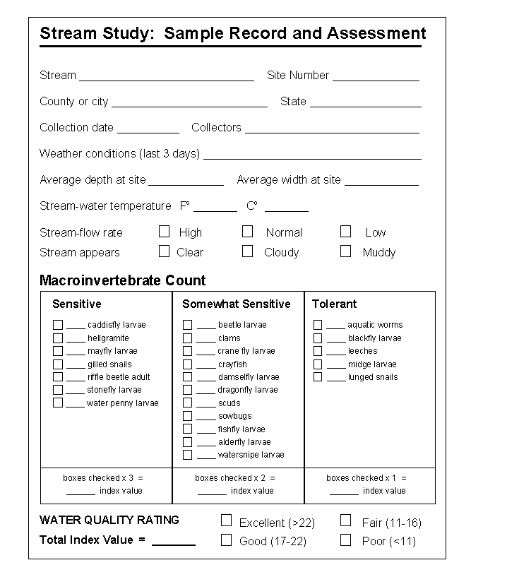**BMWP Scores Index**