**GEOG 1301 UNIT 4 REVIEW**

### **1. WATER PROPERTIES**

### Chemical

# H2O

# universal solvent

# neutral pH of 7

### Physical

* only natural substance that is found in all three states - liquid, solid (ice) and gas (steam) - at the temperatures normally found on earth … constantly interacting, changing and in movement
* freezes at 32o Fahrenheit (F) and boils at 212o F (at sea level) … the baseline with which temperature is measured
* the solid form, ice, is less dense than the liquid form, which is why ice floats
* has high specific heat index - water can absorb lot of heat before it begins to get hot
* very high surface tension - water is sticky and elastic, tends to clump together in drops rather than spread out in a thin film … surface tension is responsible for capillary action, allows water (and its dissolved substances) to move through the roots of plants and through the tiny blood vessels in our bodies
* of major importance to all living things

**2. WATER DISTRIBUTION**

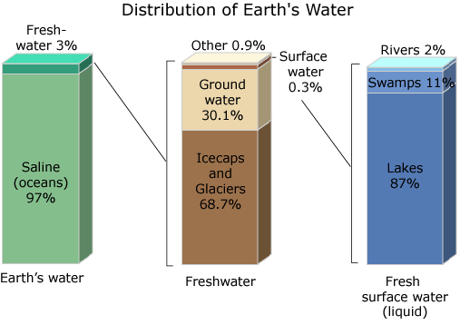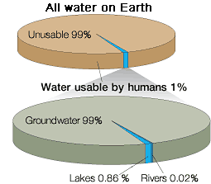

# 3. THE WATER CYCLE

1. Water storage in oceans: Saline water existing in oceans and inland seas

2. Evaporation: The process by which water is changed from liquid to a gas or vapor

Evaporation drives the water cycle

3. Sublimation: The changing of snow or ice to water vapor without melting

4. Evapotranspiration: The process by which water vapor is discharged to the atmosphere as a result of evaporation from the soil and transpiration by plants

Transpiration: The release of water from plant leaves

5. Water storage in the atmosphere: Water stored in the atmosphere as vapor, clouds and humidity

6. Condensation: The process by which water is changed from vapor to liquid

7. Precipitation: The discharge of water, in liquid or solid state, out of the atmosphere, generally on a land or water surface

8. Water storage in ice and snow: Freshwater stored in frozen form, generally in glaciers, ice fields and snowfields

9. Snowmelt runoff to streams: The movement of water as surface runoff from snow and ice to surface water

10. Surface runoff: Precipitation runoff which travels over soil surface to nearest stream channel

11. Stream flow: The movement of water in a natural channel, such as a river

12. Freshwater storage: Freshwater existing on the Earth's surface

13. Infiltration: The downward movement of water from the land surface into soil or porous rock

Ground water begins as precipitation

14. Ground-water storage: Water existing for long periods below the Earth's surface

Stored water as part of the water cycle

15. Ground-water discharge: The movement of water out of the ground

Ground water flows underground

16. Spring: Place where a concentrated discharge of ground water flows at the ground surface

# 