# GEOG 1301 UNIT 1 CONCEPT LIST

aerial photograph

Antarctic Circle

aphelion

Arctic Circle

atmosphere

biosphere

circle of illumination

conformality (conformal projection)

conic projection

cryosphere

cylindrical projection

elevation contour line

equator

equal area projection

equivalence (equivalent projection)

fractional scale

geographic information systems (GIS)

global positioning system (GPS)

graphic scale

great circle

grid system

Greenwich Mean Time (GMT)

hydrosphere

inclination of Earth’s axis

International Date Line

international system of measurement (SI)

isoline

large-scale map

latitude

lithosphere

longitude

map

map key

map projection

map scale

Mercator projection

meridian

North Pole

parallel

perihelion

physical geography

plane of the ecliptic

plane of the equator

plane projection

prime meridian

pseudocylindrical projection (elliptical)

radar

reference points

remote sensing

representative fraction

small-scale map

solar altitude

sonar

South Pole

thematic map

Tropic of Cancer

Tropic of Capricorn

Universal Time Coordinated (UTC)

verbal scale

**GEOG 1301 UNIT 1 REVIEW**

# 1. WHAT IS GEOGRAPHY?

* science of geography is likely the oldest of all sciences. Geography is the answer to the question that the earliest humans asked, "What's over there?" Exploration and the discovery of new places, new culture, and new ideas have always been basic components of geography
* geography is often called the "mother of all sciences" as studying other people and other places led to other scientific fields such as biology, anthropology, geology, mathematics, astronomy, chemistry, etc
* looks at how things differ from place to place
* has no unique body of facts or concepts it can call wholly its own
* a very broad field of inquiry … borrows its concepts from related disciplines
* both a physical science and a social science … combines characteristics of both
* interested in interrelationships … examining how various factors interrelate
* always has a spatial / distributional focus

# 2. TWO BRANCHES

* physical / environmental geography - the natural features of the earth
* human / cultural geography - human culture and its impact on the earth

# PHYSICAL GEOGRAPHY

Science as a Field of Learning (the scientific method)

* Observe phenomena that stimulates a question or problem
* Offer an educated guess (hypothesis) about the answer
* Design an experiment to test the hypothesis
* Predict the outcome of the experiment
* Conduct the experiment and observe the outcome
* Draw conclusions and formulate rules based on the experiment

Earth is a closed system / sphere that we divide into 4 sub-spheres.

* atmosphere
  + - composition
    - climate vs weather
    - energy, heat and temperature
    - pressure and wind
    - moisture
    - storms and disturbances
    - climatic zones
* hydrosphere
  + - water properties
    - water distribution
    - water cycle – oceans, evaporation, sublimation, evapotranspiration, atmosphere, condensation, precipitation, ice and snow, snowmelt, runoff, stream flow, surface water, infiltration, ground water, discharge, springs
* biosphere
  + - ecosystems
    - factors that influence ecosystems
    - biogeochemical cycles
* lithosphere
  + - soil
    - earth’s structure
    - plate tectonics
    - landforms
    - geological hazards

# HUMAN GEOGRAPHY

Two methods of study

* by region

## Areas of the earth’s surface marked by certain properties

## Devices that enable us to make spatial generalizations

## Based on criteria we establish

## Criteria can be human or physical properties or both

## All regions have

#### Area

#### Boundaries

#### Location

[*Audio Pronunciation Guide*](http://bcs.wiley.com/he-bcs/Books?action=mininav&bcsId=4608&itemId=0470237139&assetId=152419&resourceId=14558&newwindow=true)

* by concept / theme
  + Physical (environmental) geography - more problem oriented
    - atmosphere – atmospheric hazards, global warming
    - hydrosphere – distribution, use, flooding, oceans
    - biosphere – deforestation, desertification, food resources
    - lithosphere – geological hazards
  + Cultural (coherence and diversity) geography
    - learned, shared behavior … way of life
    - cultural diffusion
    - cultural conflict
    - language
    - ethnic culture
    - religion
  + Demography (population and settlement)
    - population size and distribution
    - population growth and change
    - demographic transition model
    - migration patterns
    - settlement patterns
    - urbanization
  + Political (geopolitical) geography
    - nation-states
    - boundaries
    - colonialism
    - fragmentation and unity
    - international and supranational organizations
  + Economic (development) geography
    - more / less developed
    - core-periphery model
    - indicators or economic development
    - indicators of social development
    - sustainable development

# 3. THE GEOGRAPHIC GRID

A system of accurate location is necessary to pinpoint with mathematical precision the position of any spot on Earth’s surface.

The grid system is the simplest technique, using a network of intersecting lines.

Four Earth features provide the set of reference points essential to establish an accurate locational system.

* North Pole
* South Pole
* rotation axis
* equatorial plane

If a plane passing through the middle of a sphere dividing it into two equal halves, it creates what we call a great circle (the largest circle we can draw on a sphere).

* Equator
* Circle of Illumination

Latitude—the distance measured north and south of the equator … expressed in degrees, minutes and seconds.

Equator, 0°

North Pole, 90° N

South Pole, 90° S

Tropic of Cancer, 23.5° N

Tropic of Capricorn, 23.5° S

Arctic Circle, 66.5° N

Antarctic Circle, 66.5° S

statute miles or 1.85 kilometers).

Longitude—the distance measured east and west on Earth’s surface.

prime meridian—the meridian passing through the Royal Observatory at Greenwich, England. We measure longitude from this meridian both east and west to a max of 180°.

**4. MAPS**

two-dimensional representation of the spatial distribution of selected phenomena

* map attributes
  + - distance
    - direction
    - size
    - shape
    - show distribution of one or more phenomena
  + map limitations
    - no map is perfectly accurate
    - impossible to show curved earth on flat surface without distortion
    - equivalence (relative size) vs conformality (shape)

MAP SCALE

relationship between length measured on map and corresponding distance on ground

### Scale Types

* Graphic Map Scales - Uses a line marked off in graduated distances
* Fractional Map Scales - Uses a ratio or fraction to express the comparison of map distance with ground distance
* Verbal Map Scales - uses words to give the ratio of the map scale length to the distance on the ground

### Large and Small Scale

concepts of large and small are comparative, not absolute

* Large-scale map— has a relatively large representative fraction, which means the denominator is small — 1/10,000 is large-scale as compared to 1/1,000,000.

Portrays only a small portion of Earth’s surface, providing considerable detail.

* Small-scale map — has a small representation fraction, which means the denominator is large.

Portrays a larger portion of Earth’s surface, but gives only limited detail.

# MAP ESSENTIALS

* Title — brief summary of map’s content or purpose and identify area it covers
* Orientation — show direction through a compass rose, geographic grid or north arrow
* Date — the time span in which the map’s data were collected
* Legend — explain any symbols used in the map to represent features / quantities
* Scale — a graphic, verbal or fractional scale to indicate the relationship between length measured on the map and corresponding distance on the ground
* Location — a grid system, either a geographic grid using latitude and longitude or an alternative system that is expressed like the *x* and *y* coordinates of a graph
* Data Source — the data source for thematic maps
* Projection type — the type of projection, particularly for small-scale maps

##### MAP PROJECTIONS

problem – imagine a large transparent globe with many features. You carefully cover the globe with a sheet of paper. You turn on a light bulb at the center of the globe and then trace all of the features onto the paper. Carefully remove the paper and flatten it on the table.

equivalence (relative size) vs conformality (shape)

can’t do both – which do you sacrifice?

* Cylindrical Projections - created by mathematically “wrapping” a globe in a cylinder

mercator projection — a special-purpose projection that was created more than 400 years ago as a tool for straight-line navigation

distorts size - for example, Greenland appears much larger than Africa, South America and Australia, although Greenland is actually smaller than them. Africa is 14 X larger than Greenland.

* Planar Projections - created by projecting the markings of a center-lit globe on a flat piece of paper.

no more than one hemisphere can be displayed

* Conic Projections - created by projecting the markings of a center-lit globe onto a cone wrapped tangent to, or intersecting, a portion of the globe

because of the distortion associated with them, they are better suited for mapping smaller regions (i.e., a single country)

* Pseudocylindrical Projections - are generally designed to show the entire globe … These projections usually employ a central parallel and a central meridian that cross at right angles in the middle of the map.

Distortion usually increases in all directions away from the point where these lines cross.

* Interrupted Projections - a technique used to minimize distortion … Ocean regions are usually split apart or “interrupted” so that the distortion over landmasses is minimized.

The result is a map with very little distortion over land and great gaps over the oceans.

# GEOG 1301 UNIT 2 CONCEPT LIST

causal relationship

closed system

common knowledge

conclusion

control group

controlled experiment

correlational relationship

cumulative research

data

dependent variable

experimental group

hypothesis

if-then logic

independent variable

objectivity

observation

prediction

qualitative data

quantitative data

question

reliability

replication

statistical analysis

theory

untested observation

validity

**GEOG 1301 UNIT 2 REVIEW**

**steps in THE RESEARCH PROCESS**

1. statement of the problem
2. review of the literature
3. development of the hypotheses / statement of research objectives
   1. hypothesis
   2. independent variable
   3. dependent variable
   4. direction of relationship – positive/direct, negative/inverted
   5. type of relationship – causal, correlational
4. choice of research design
   1. qualitative
   2. quantitative
   3. reliability
   4. validity
5. data collection
   1. random sampling
   2. systematic sampling
   3. stratified sampling
6. data analysis and interpretation
   1. objectivity
   2. statistical analysis
7. development of conclusions
8. posing new research questions

[*The Scientific Method* handout]

**GEOG 1301 UNIT 3 CONCEPT LIST**

area sampling

compass

data

data sheet

graph

grid

line sampling

objectivity

observation

point sampling

population

quadrat

random sampling

sample

sampling

stratified sampling

succession

systematic sampling

transect

x-axis

y-axis

HYDROSPHERE FIELDWORK

fluvial systems

pH strips

secchi disc

test strips

water monitoring kit

water thermometer

BIOSPHERE FIELDWORK

ACFOR Scale for Measuring Species Abundance

aerial net

Algae Groups Chart

Algae Identification Guide

BMWP Identification Chart

BMWP Scores Index

diameter vs circumference

field guides

forceps

identification keys

invertebrate

lichen

Lichen Identification Chart

macroinvertebratepollution tolerant

pond net

scraper

species

sweep net

taxonomy

Tree Species Guide

Visually Identifying Algae Chart

ATMOSPHERE FIELDWORK

anemometer

Beaufort Wind Scale

calculator

Cloud Cover Scale

cloud types

Dew Point Temperature Table

luxmeter

okta

rain gauge

Relative Humidity Table

sling psychrometer

wind vane

SOIL FIELDWORK

chemical testing

free carbonates

infiltration tube

Munsell Color Chart

mustard solution

nitrogen

ped

pH

pH meter

phosphorus

potash

rebar

soil color

soil consistence – 4 types

soil core / auger

Soil Moisture Content Chart

soil structure – 7 types

Soil Structure Chart

soil texture – 11 types

Soil Texture Triangle

stop watch

temperature probe

**GEOG 1301 UNIT 3 REVIEW**

**1. FIELD SAMPLING TECHNIQUES**

A. SAMPLING TECHNIQUES

1. RANDOM SAMPLING

A. Random Point Sampling

B. Random Line Sampling

C. Random Area Sampling

D. Advantages and Disadvantages of Random Sampling

2. SYSTEMATIC SAMPLING

A. Systematic Point Sampling

B. Systematic Line Sampling

C. Systematic Area Sampling

D. Advantages and Disadvantages of Systematic Sampling

3. STRATIFIED SAMPLING

A. Stratified Systematic Sampling

B. Stratified Random Sampling

C. Advantages and Disadvantages of Stratified Sampling

B. FIELD SAMPLING METHODS

#### 1. vertical transect

#### 2. random sample points in a permanent area

3. random walk

4. flagged transect

5. succession transects

C. FIELD DATA COLLECTION METHODS

#### 1. species abundance at random sample points

2. total counts of species abundance

3. succession studies

[*Stages of Plant Succession and Associated Wildlife Species in a Typical South Plains Habitat* handout, *Vertical Layering in a Typical South Plains Habitat* handout]

4. data collection using equipment

**2. FIELD WORK PROTOCOLS**

[see *Field Work Protocols* handout]

**3. ATMOSPHERE FIELD WORK**

wind direction and velocity

air temperature

relative humidity

dew point

light level / intensity

amount of cloud cover and cloud type

precipitation

**4. HYDROSPHERE FIELD WORK**

channel width – current, bank-full

depth

wetted perimeter

velocity

bed load size

cross-sectional area

discharge

efficiency

obtaining water samples

water temperature

lake water chemistry and turbidity

stream water chemistry and turbidity

**5. BIOSPHERE FIELD WORK**

algae identification

invertebrate sampling

animal, herb and shrub plots

random pairs tree analysis

presence of particulate pollution

lichen identification

[*Map of Texas Ecosystems* handout]

**6. SOIL FIELD WORK**

obtaining a soil sample

moisture content

soil structure, color, consistence and texture

presence of roots and rocks

test for free carbonates

soil chemistry

infiltration rate

soil temperature

earthworm census

**7. OPTIONAL FIELD WORK HANDOUTS**

*Field Sketching*

*Diagramming a Study Site*

*Writing a Formal Investigation*

*Creating a Scientific Poster*

*Preparing and Presenting a Scientific Talk*

# GEOG 1301 UNIT 4 CONCEPT LIST

aquifer

condensation

evaporation

evapotranspiration

global conveyer-belt circulation

groundwater

hydrologic cycle

infiltration

lake

permeability

porosity

runoff

salinity

snow melt

spring

stream flow

sublimation

surface runoff

tide

transpiration

water table

zone of saturation

**GEOG 1301 UNIT 4 REVIEW**

### **1. WATER PROPERTIES**

### Chemical

# H2O

# universal solvent

# neutral pH of 7

### Physical

* only natural substance that is found in all three states - liquid, solid (ice) and gas (steam) - at the temperatures normally found on earth … constantly interacting, changing and in movement
* freezes at 32o Fahrenheit (F) and boils at 212o F (at sea level) … the baseline with which temperature is measured
* the solid form, ice, is less dense than the liquid form, which is why ice floats
* has high specific heat index - water can absorb lot of heat before it begins to get hot
* very high surface tension - water is sticky and elastic, tends to clump together in drops rather than spread out in a thin film … surface tension is responsible for capillary action, allows water (and its dissolved substances) to move through the roots of plants and through the tiny blood vessels in our bodies
* of major importance to all living things

**2. WATER DISTRIBUTION**

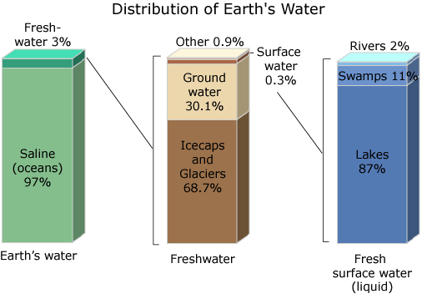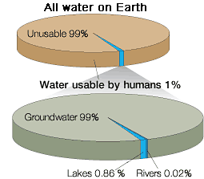

# 3. THE WATER CYCLE

1. Water storage in oceans: Saline water existing in oceans and inland seas

2. Evaporation: The process by which water is changed from liquid to a gas or vapor

Evaporation drives the water cycle

3. Sublimation: The changing of snow or ice to water vapor without melting

4. Evapotranspiration: The process by which water vapor is discharged to the atmosphere as a result of evaporation from the soil and transpiration by plants

Transpiration: The release of water from plant leaves

5. Water storage in the atmosphere: Water stored in the atmosphere as vapor, clouds and humidity

6. Condensation: The process by which water is changed from vapor to liquid

7. Precipitation: The discharge of water, in liquid or solid state, out of the atmosphere, generally on a land or water surface

8. Water storage in ice and snow: Freshwater stored in frozen form, generally in glaciers, ice fields and snowfields

9. Snowmelt runoff to streams: The movement of water as surface runoff from snow and ice to surface water

10. Surface runoff: Precipitation runoff which travels over soil surface to nearest stream channel

11. Stream flow: The movement of water in a natural channel, such as a river

12. Freshwater storage: Freshwater existing on the Earth's surface

13. Infiltration: The downward movement of water from the land surface into soil or porous rock

Ground water begins as precipitation

14. Ground-water storage: Water existing for long periods below the Earth's surface

Stored water as part of the water cycle

15. Ground-water discharge: The movement of water out of the ground

Ground water flows underground

16. Spring: Place where a concentrated discharge of ground water flows at the ground surface

# GEOG 1301 UNIT 5 CONCEPT LIST

abiotic

apparent diversity

biogeochemical cycle

biomass

biome

biotic

carbon cycle

carnivore

carrion

climax vegetation

community

competition – interspecific and intraspecific

decomposer

decomposition

desert

diversity / biodiversity

ecosystem

effective diversity

exotic species

fauna

flora

food chain

food pyramid

forest

geographic distribution

grassland

herbivore

invasion

invertebrate

limiting factor

litter

nitrogen cycle

nitrogen fixation

oxygen cycle

phosphorus cycle

photosynthesis

plant respiration

plant succession

population

primary consumers

primary production

producers

resistance barrier

secondary consumers

secondary production

shrub land

species

subspecies

succession

sulpher cycle

symbiosis

tolerance

tree line

trophic level

tundra

vertebrate

vertical zonation

water cycle

wetland

woodland

**GEOG 1301 UNIT 5 REVIEW**

The **biosphere** is the biological component of earth systems and includes all living organisms on earth.

The biosphere has evolved since the first single-celled organisms originated 3.5 billion years ago in an atmosphere composed primarily of carbon dioxide.

Billions of years of primary production by plants released oxygen from the carbon dioxide and deposited the carbon in sediments, eventually producing the oxygen-rich atmosphere we know today. Free oxygen has made possible life as we know it while transforming the chemistry of earth systems forever.

A key component of earth systems, the biosphere interacts with and exchanges matter and energy with the other spheres, helping to drive the global biogeochemical cycling of carbon, nitrogen, phosphorus, sulfur and other elements.

The biosphere comprises the totality of biodiversity on earth and performs all manner of biological functions, including photosynthesis, respiration, decomposition, nitrogen fixation and production.

##### 1. LEVELS OF INTERACTION

The interrelationship of living things and their environments characterizes the biosphere.

Biomes - broad major groupings of natural ecosystems that include animal and plant life

biome map and pictures <http://www.geog.ubc.ca/~ldaniels/biomes/explore/>

Ecosystem - grouping of plants, animals, microbes, etc. interacting with each other and the physical environment

***Abiotic factors*** - elements of an ecosystem that are non-living. Nevertheless, they still have an effect on the ecosystem. Water, temperature, relief, soil type, fire and nutrients are all examples of abiotic factors.

***Biotic factors*** - living elements of an ecosystem, i.e. plants and animals. All biotic factors require **energy** to survive. These living organisms form a community within an ecosystem. Geographers divide the world into major large-scale ecosystems, called biomes.

Community - all plants and animals inhabiting an area (suggests interactions)

Population - group of individuals of the same species in an area

Species - group of organisms where all members do or have the potential to interbreed & produce viable offspring

Subspecies - anatomically different but still able to interbreed

# 2. FACTORS THAT INFLUENCE ECOSYSTEMS

#### The Food Chain

The vegetation at a site is the foundation of all other populations living there.

Primary production is the conversion of atmospheric carbon to plant biomass through the process of photosynthesis. This process requires that plants have access to resources other than CO2 to support production. These include solar radiation, water, nutrients and appropriate temperatures.

Small spaces may not have sufficient resources to support large herbivores (animals that consume vegetation) or carnivores (animals that consume other animals).

Animals not residing in the area may consume plant and animal matter there and then export the consumed nutrients by leaving for another area. Thus, the apparent diversity (range of organisms we observe in a space) may be lower than the effective diversity (range of organisms that use a space).

# Invasion

All of the organisms in a space moved there, or invaded, at some time in the past. We have historic examples of changes that resulted from human introductions.

Invasions of organisms create the diversity of organisms in a place.

It is not likely that all occupants of a space invaded at the same time.

Species differ considerably in their abilities to disperse into new spaces and in their tolerances of newly available environments.

Later arriving species have to pass through a resistance barrier of already occupied spaces.

Humans have significantly altered the process by creating avenues for more rapid migration or by creating barriers to movement.

# Geographic Distribution

The geographic distribution of species results from many factors.

Changing one factor may not necessarily lead to a radical alteration of these patterns.

How sensitive a species is to changes in single factors depends on a variety of factors.

### Limiting Factors

What factors limit a species’ productivity (*limiting factors*)?

*Genetic factors* - Different organisms have different productive potential owing to their genetic makeup in any given site.

*Geographic location and site factors* - Places in the landscape (hills, valleys and uplands) have local variations in solar radiation, water and soil resources, and are subject to different types and frequencies of disturbances (processes like fire, wind fall, erosion, landslides, etc. that eliminate or decrease the short- to long-term viability of an organism).

*Trophic level and biotic interactions* - The diversity of organisms and their distribution among the trophic levels (position of an organism in the food chain) can limit long-term production. The degree of mutual benefit derived from sharing resources is important to long-term productivity. The truest form of mutual benefit/dependence is in the symbiotic relationship between two organisms, a relationship in which both organisms mutually require the presence of the other.

*Pests, predators, disease and other disturbances* - These are aspects of a changing, interactive biotic system … aspects that capture or divert resources needed for production of a given organism. They may even eliminate some organisms.

*Time* - Production varies over time as a result of the variability in all of the above factors. Productivity increases and decreases over the course of the year. Both too little of a resource and too much of one will reduce production.

###### Succession

Succession refers to a change in species composition over time. It’s thought to be directional and predictable.

*Primary Succession* - succession of plant communities of new land/soil

*Secondary succession* – previously vegetated land that has been recently disturbed

*Disturbance succession* – where disturbance creates/initiates the succession process

*Facilitation* - species create favorable environment for new species

*Individualistic* – random occurrence of species … they happen to be able to survive

Tolerance

Tolerance is the degree that an organism can withstand a certain factor, for example optimum temperature, range of tolerance, limit of tolerance or environmental gradients.

#### Competition

interspecific competition and intraspecific competition (social behavior)

#### Abiotic Factors

temperature fire soils (mineral component)

water terrain climate/weather

## Diversity

The idea of biodiversity encompasses several types of diversity - genetic diversity, population diversity, species diversity, trophic diversity, habitat diversity.

# 3. BIOGEOCHEMICAL CYCLES

chart combining all cycles

http://essp.csumb.edu/esse/climate/climatefigures/climFig1.html

The Food Chain

All nutrients originated from weathered rock.

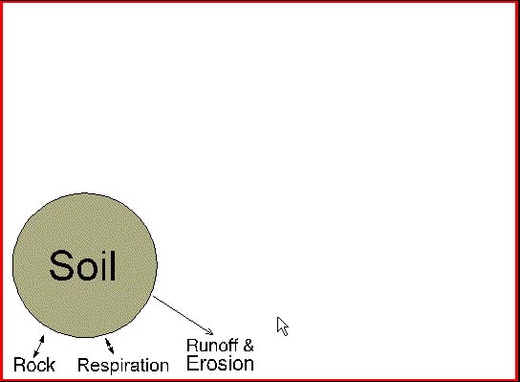

Photosynthesizing organisms evolved to create biogeochemical cycle.

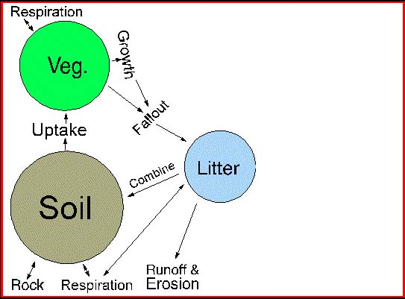

Micro-organism additions to the biogeochemical cycle accelerated litter decomposition.

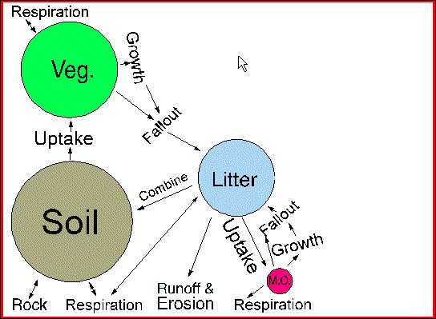

Herbivores evolved to capture standing vegetation.

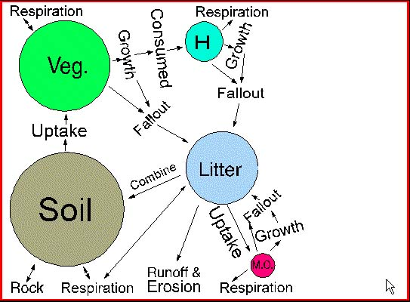

Carnivores evolved to consume nutrients in herbivores.

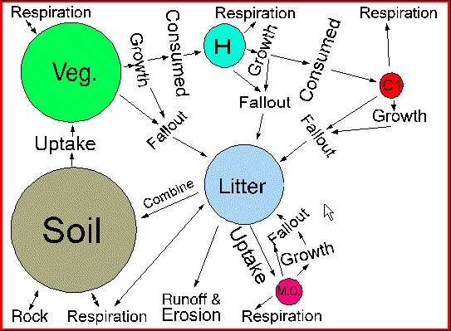

Top carnivores evolved to consume nutrients in other carnivores and herbivores.

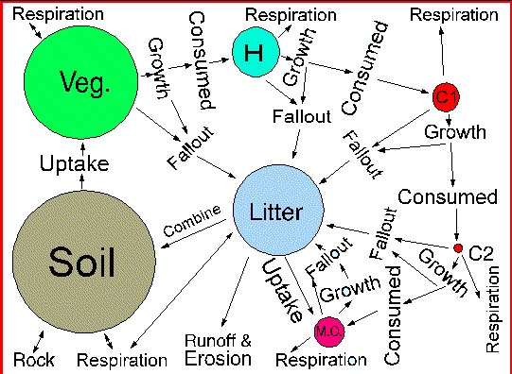

Carrion eaters joined the cycle to consume dead carnivores and herbivores.

Micro-organisms clean up after all other organisms, returning nutrients to the soil.

#### Photosynthesis

the process in which carbon dioxide (CO2) and water (H2O) are used to produce carbohydrates and evolve oxygen (O2) in the presence of light and chlorophyll; the net result is light energy (radiant energy) is converted into chemical energy in the form of fixed carbon compounds (carbohydrates)

<http://www.cnr.vt.edu/DENDRO/forestbiology/photosynthesis.swf>

Water Cycle <http://ga.water.usgs.gov/edu/watercyclehi.html>

Carbon Cycle <http://essp.csumb.edu/esse/climate/climatefigures/Ccycle.html>

Nitrogen Cycle <http://essp.csumb.edu/esse/climate/climatefigures/Ncycle.html>

Phosphorus Cycle

<http://arnica.csustan.edu/carosella/Biol4050W03/figures/phosphorus_cycle.htm>

Sulfur Cycle <http://essp.csumb.edu/esse/climate/climatefigures/Scycle.html>

# GEOG 1301 UNIT 6 CONCEPT LIST

# absorption

# adiabatic cooling

# adiabatic warming

# advection

# air mass and pressure

# albedo

# atmospheric pressure

# average annual temperature range

# barometer

# capacity

# carbon dioxide

# cirrus clouds

# climate

# climograph

# cloud

# cold and warm fronts

# condensation and condensation nuclei

# conduction

# controls of weather and climate

# convection

# Coriolis effect

# cumulonimbus clouds

# cumulus clouds

# cyclone

# dew

# dew point (dew point temperature)

# El Niño

# elements of weather and climate

# energy

# evaporation

# evapotranspiration

# eye and eye wall

# fog

# friction layer

# front

# frontal lifting

# Fujita Tornado Intensity Scale

# funnel cloud

# global warming

# greenhouse effect

# greenhouse gases

# hail

# heat

# high

# humidity and relative humidity

# hurricane

# hydrologic cycle

# insolation

# intertropical convergence zone (ITCZ)

# isobar

# isotherm

# isohyet

# jet stream

# kinetic energy

# Köppen climate classification system

# latent heat

# lightening

# low

# millibar

# monsoon

# ocean current

# offshore and onshore flow

# particulates (aerosols)

# precipitation

# pressure gradient

# radiant energy

# radiation (emission)

# rain

# reflection

# ridge

# Saffir-Simpson Scale

# saturated adiabatic rate

# saturation

# scattering

# sensible temperature

# snow

# specific heat

# specific humidity

# stable (air)

# stationary front

# storm surge

# stratocumulous clouds

# stratus clouds

# sublimation

# supercooled water

# supersaturated (air)

# surface tension

# temperature

# temperature inversion

# terrestrial radiation

# thermal energy

# thermal high

# thermal low

# thermocline

# thermometer

# thunder

# thunderstorm

# tornado

# trade winds

# transmission

# trough

# unstable (air)

# upwelling

# vapor pressure

# water vapor

# weather

# westerlies

# wind

# GEOG 1301 UNIT 6 REVIEW

# 1. ATMOSPHERE

# Divide atmosphere vertically into four layers based on temperature.

# All of the earth's weather occurs in the troposphere.

# Nitrogen and oxygen make up 99% of atmosphere.

# Water vapor also exists in small amounts.

# Energy transferred between earth's surface and atmosphere via

# conduction

# convection

# radiation

# [*Earth-Atmosphere Energy Balance* handout]

# Oceans play important role in exchanging and transporting heat and moisture in atmosphere.

# Oceans and atmosphere interact extensively.

# Ocean currents play significant role in transferring heat toward pole.

# Atmosphere always in a state of dynamic equilibrium.

# 2. CLIMATE VS WEATHER

# climate – average weather over a long period of time

# weather – current atmospheric conditions – temperature, rainfall, wind and humidity – at a given place

# 3. KÖPPEN CLIMATE CLASSIFICATION SYSTEM

# five major climate types based on temperature and precipitation

# A - Moist Tropical Climates

# B - Dry Climates

# C - In Humid Middle Latitude Climates

# D - Continental Climates

# E - Cold Climates

# subgroups distinguish specific seasonal characteristics of temperature and precipitation

# f - moist with adequate precipitation in all months, no dry season … usually A, C & D

# m - rainforest climate in spite of short, dry season in monsoon type cycle … only A

# s - dry season in summer

# w - dry season in winter

# further denote variations in climate with third letter

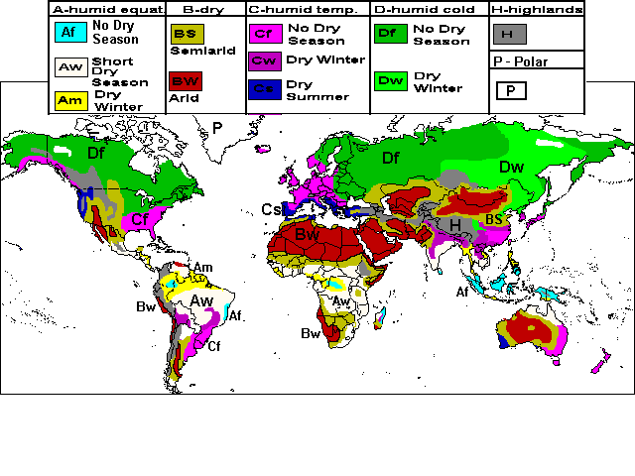

# 4. FACTORS AFFECTING CLIMATE AND WEATHER

# air temperature

# air humidity

# type and amount of cloudiness

# type and amount of precipitation

# air pressure

# wind speed and direction

# climate controls drive atmospheric processes

# [*Climate* *Control* handout]

# latitude

# ocean currents

# wind and air masses

# elevation

# relief

# near water

# 5. AIR MASSES AND FRONTS

# air mass – large mass of air with nearly uniform temperature and humidity that moves mostly in a horizontal direction

# source region defines temperature and moisture characteristics, and classification

# polar – cold

# tropical – warm

# equatorial – originating near equator

# maritime – moist

# continental – dry

# front - boundary between two different interacting air masses

# [*Identifying Air Masses and Fronts* handout]

# 6. INTERPRETING THE WEATHER

# Climographs are a graphic way of displaying average temperature and rainfall



# data used in interpreting weather:

# temperature type of weather

# dew point temperature cloud cover

# air pressure wind direction and speed

# [*Interpreting Surface Observation Symbols* handout]

# 7. WEATHER DISTURBANCES

# TORNADOES

|  |  |  |
| --- | --- | --- |
| Before thunderstorms develop, a change in wind direction and an increase in wind speed with increasing height create an invisible, horizontal spinning effect in the lower atmosphere. | Rising air within the thunderstorm updraft tilts the rotating air from horizontal to vertical. | An area of rotation, 2-6 miles wide, now extends through much of the storm. Most strong and violent tornadoes form within this area of strong rotation. |

# Types

# multiple vortex tornado water spout

# satellite tornado land spout

# Characteristics

# shape rotation

# size sound

# appearance electromagnetic

# Fujita Tornado Intensity Scale

# HURRICANES

# Stages of Development

|  |  |  |
| --- | --- | --- |
|  |  |  |

# Parts of a Hurricane

# Outflow The Eye The Eye Wall

# Feeder Bands Storm Surge

# Saffir-Simpson Scale

# GEOG 1301 UNIT 7 CONCEPT LIST

SOIL

addition

A horizon

B horizon

C horizon

calcification

gleization

E horizon

eluviation

field capacity

gleization

humus

illuviation

laterization

leaching

litter

loam

O horizon

parent material

pedogenic processes

pedogenic regime

ped

podzolization

R horizon

regolith

removal

salinization

soil

soil horizon

soil order

soil profile

soil taxonomy

transformation

translocation

LANDFORMS

aeolian processes

coastal processes

crust

erosion processes

external processes

fluvial processes

geomorphology

glacial processes

inner core

internal processes

landform

lava

lithosphere

magma

mantle

outcrop

outer core

regional metamorphism

relief

rock

rock cycle

sedimentary rock

solution processes

strata

topography

uniformitarianism

INTERNAL PROCESSES

caldera

cinder cone

composite volcano

continental drift

continental rift valley

convergence zone

divergent boundary

earthquake

epicenter

faulting

folding

graben

horst

lava dome

magnitude

mantle plume

mid-ocean ridge

normal fault

oceanic trench

Pangaea

seafloor spreading

shield volcano

strike-slip fault

subduction

tectonic plates

thrust fault

transform boundary

vulcanism

EROSION PROCESSES

biological weathering

carbonation

chemical weathering

creep

erosion

exfoliation

frost wedging

joints

landslides

mass wasting

mechanical weathering

mudflow

oxidation

rock fall

salt wedging

scree

slump

solifluction

talus cones

weathering

FLUVIAL PROCESSES

aggradation

alluvial

antecedent stream

base level

bed load

braided stream

capacity

consequent stream

delta

discharge

dissolved load

drainage basin

floodplain

fluvial processes

lateral erosion

meandering stream

oxbow lake

perennial stream

stream capture

subsequent stream

suspended load

watershed

SOLUTION PROCESSES

carbonic acid

cavern

dissolution

hydrothermal activity

karst

slink hole

AEOLIAN PROCESSES

alluvial fan

blowout

bornhardt

butte

deflation

differential erosion

erg

hamada

loess

mesa

plateau

playa

reg

sand dune

sapping

scarp

slip face

GLACIAL PROCESSES

alpine glacier

ablation zone

accumulation zone

basal slip

cirque glacier

col

continental glacier

drumlin

equilibrium line

esker

glacial drift

glacial plucking

glacial trough

ground moraine

hanging valley

kettle

COASTAL PROCESSES

abrasion

atoll

backwash

barrier island

barrier reef

beach

beach drifting

fjord

fringing reef

jetty

lagoon

longshore current

marine terrace

spit

swash

swell

tombolo

tsunami

wave height

wave refraction

**GEOG 1301 UNIT 7 REVIEW**

**1. SOIL**

factors of soil formation

* climate
* organisms
* relief
* parent material

# time

Soil Horizons

* **O horizon** - The top layer of soil composed primarily of organic material, such as the litter of leaves and plants, insects and microorganisms.
* **A horizon** - Also known as the topsoil, where seeds germinate and plants' roots thrive.
* **E horizon** - Composed of sand and silt. Minerals and clay have been removed in a process known as eluviation.
* **B horizon** - Also known as the subsoil, this layer contains mineral deposits that have settled down from upper layers.
* **C horizon** - This layer is called the regolith and consists of rocks and little organic material (even roots don't penetrate this layer).
* **R horizon** - The "R" in R horizon stands for rock and it refers to the unconsolidated rock or solid bedrock of this layer.

Soil horizons form because of four development processes:

* **addition** – material added to the soil by wind, rain, decomposition and etc.
* **transformation** – changes in materials added to soil from chemical and biological processes
* **translocation** – the movement of material throughout the soil by water, animals and etc.
* **removal** – removal of materials from the soil

All the horizons taken together comprise the **soil profile**.

The properties of a soil are determined by the process under which they form. Though all soils are created by the processes of addition, transformation, translocation and removal, it is the soil forming or, **pedogenic processes**, that determine the kind of soil that is ultimately formed.

**Laterization** produces the deep red to bright orange-red soils of the tropics.

**Calcification** - occurring in warm, semi-arid environments, usually under grassland vegetation – produces soil rich in organic matter.

**Podzolization** occurs in cool and moist climates under pine forests and produces soil heavily leached and basically composed of a light colored layer of sand.

**Salinization** produces the saline soils that are common in desert and steppe climates.

**Gleization** occurs in waterlogged regions producing soil in which dead vegetation has accumulated in thick layers.

Finally, there are [twelve key **orders of soil**](http://soils.ag.uidaho.edu/soilorders/) in soil taxonomy. Most common around the world are Aridisols (desert soils), Inceptisols (weakly developed, infertile soil) and Alfisols (reasonably fertile clayish soils). Mollisols (humus-rich) are best for agriculture and occupy approximately one quarter of the US. (See Soil Taxonomy at<http://soils.ag.uidaho.edu/soilorders/>.)

**2. EARTH’S STRUCTURE**

The outer brittle shell of the earth is the **crust**. The crust is broken into several continental and oceanic **tectonic plates**. These plates ride atop the more pliable mantle beneath. The **mantle** makes up 80% of the Earth's total volume. It is mainly composed of a dark, dense rock called *peridotite* that is rich in iron and magnesium. The **core** is divided into the inner and outer cores. Though intense heat is generated at such great depths, geoscientists believe that under the enormous overlying pressure the inner core is made of solid iron and nickel. The outer core is thought to be molten iron and it is the interaction between the inner and outer core that produces Earth's magnetic field.

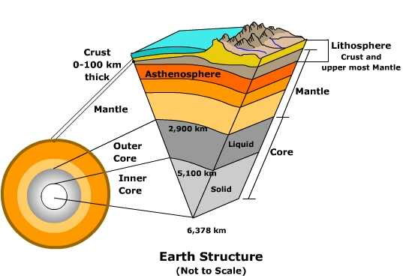

**3. INTERNAL PROCESSES**

Deep within the earth's core, the radioactive decay of elements like uranium, thorium and potassium generate heat. The heat transfers upward to warm the mantle causing it to slowly circulate and tug on the plates above. As the **tectonic plates** move, they interact by colliding (**collision**), sliding by or over one another (**subduction**) or moving away from one another (**divergence**). The result of such movement produces faults and earthquakes, volcanoes, the creation of mountain systems or deep valleys and trenches. The great mountain systems of earth like the Himalayas are a product of the collision of tectonic plates. Similarly, plate interaction causes the huge trenches found on the ocean floor, like the Marianas Trench.

**Plate Tectonic Theory**

* Plate - large crustal section of the earth’s surface
* Tectonic - movement of the earth
* Plate Tectonics - a unifying theory … explains the formation of continents, mountains, earthquakes, volcanoes … crust of the earth shifts 1-3 inches per year

**4. GEOMORPHOLOGY**

Geomorphology is the science of landforms with an emphasis on their origin, evolution, form and distribution across the physical landscape.

* built up landforms created by tectonic processes
* leveled landforms created by gradational processes – weathering, mass wasting, erosion, deposition

**Simple Model of Landform Development**

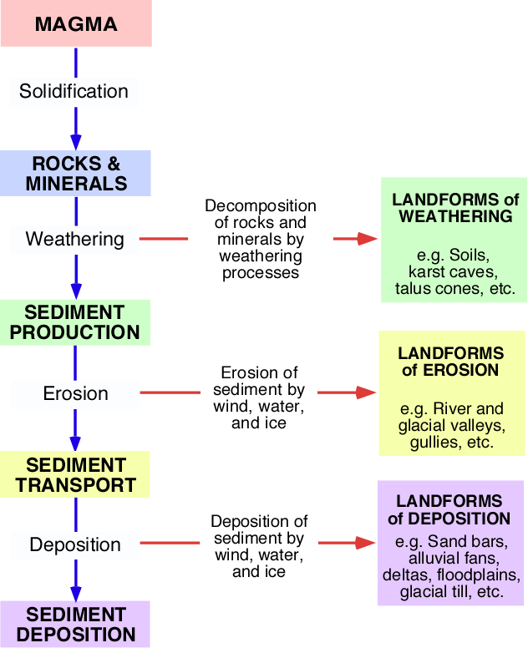

I. Weathering

weatheringprocesses

Chemical – hydrolysis**,** oxidation**,** reduction**,** hydration**,** carbonation**,** solution, decomposition

Physical/Mechanical – abrasion**,** crystallization**,** thermal insolation**,** wetting and drying**,** pressure release, frost, salt wedging, organic, unloading

weatheringproducts

regolith

soil

limestone landforms - karst, cave, spring, underground water channel, deposit from evaporation

**II. Erosion and Deposition**

erosion and deposition processes erosion and deposition products

plucking flocculation river valley sand bar

cavitation solution glacial valley alluvial fan

raindrop impact traction gully delta

abrasion saltation flood plain glacial till

entrainment suspension

**III. Hill Slope and Mass Movement**

hill slope and mass movement processes

rain splash stream channel rock slide

rain wash rotational slip solifluction

runoff slumping soil creep

sheet wash avalanche mudflow

[rill](http://www.physicalgeography.net/physgeoglos/r.html#anchor140172) rock fall landslide

Hill slope and mass movement products are self-evident.

**IV. Fluvial**

fluvial processes fluvial products

erosion fluid drag braided channel flood plain

deposition bank-caving meandering channel crevasse

stream discharge entrainment sand bar flood plain depression

flooding suspension gravel bar oxbow lake

point bar saltation point bar delta

meandering traction riffle alluvial fan

overbank flow, flooding aggradation scoured pool

**V. Coastal and Marine**

coastal and marine processes coastal and marine products

erosion beach drift beach spit

[sediment](http://www.physicalgeography.net/physgeoglos/s.html#anchor215347) [transport](http://www.physicalgeography.net/physgeoglos/t.html#anchor195185) rip current wave-cut notch bay head beach

wave action longshore current sea cliff barrier beach

friction longshore drift cave bay-mouth bar

deposition littoral drift sea arch tombolo

swash tidal current sea stack cuspate forelandbackwash

**VI. Glacial**

glacial processes

physical weathering basal sliding

pressure melting mass balance

abrasion mass movement - solifluction, gelifluction, frost creep, rock fall

melting evaporation

sublimation calving

scouring plucking

freeze-thaw process frost creep

insolation weathering erosion - nivation, eolian erosion and deposition, fluvial erosion and deposition

glacial products

glacial polish terminal moraine kettle hole

glacial milk recessional moraine pingo

roche mouton née drumlin palsa

hanging valley esker patterned ground

cirque lateral moraine sand sheet

cirque glacier kame loess

horn medial moraine sand dune

arête outwash deposit nivation hollow

talus glacial drift sand wedge

striation outwash plain ice wedge

glaciofluvial deposit closed talik through talik

till talik erratic

till plain

**VII. Eolian (Desert)**

eolian processes eolian products

erosion deflation hollow dune field

wind deposition pan wind ripple

traction desert pavement blowout

creep reg loess

saltation sand dune – barchan, transverse, parabolic, barchanoid ridge, longitudinal, seif, star dune, dome, reversing

# GEOG 1301 UNIT 8 CONCEPT LIST

causal chain

chain reaction

earth system science analysis

event

event > sphere interaction

feedback loop

interaction

sphere > event interaction

sphere > sphere interaction

system sphere

**GEOG 1301 UNIT 8 REVIEW**

**EARTH SYSTEM SCIENCE ANALYSIS**

Earth System Science analysis, or ESS analysis, examines each event to sphere, sphere to event and sphere to sphere interaction.

An ESS analysis has four steps, which include looking at

* how the event affects each of the spheres,
* how each sphere affects the event,
* how the spheres affect each other, and
* connecting the interactions.

Step 1: Event > Sphere Interactions

How could an event affect each sphere? The answers to this question are the event > sphere impacts.

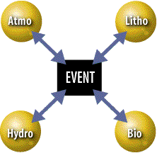

Step 2: Sphere > Event Interactions

How could each sphere affect the event? The answers to this question are the sphere > event impacts.

Step 3: Sphere > Sphere Interactions

How can each sphere affect the other spheres? The answers to this question are the sphere > sphere impacts.

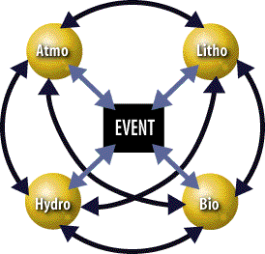

Step 4: Causal Chains

The interactions that occur within Earth's system actually occur as a series of chain reactions, which ripple through Earth's spheres like waves that spread out from a pebble tossed in a still pond. This means that an event often leads to a change in one sphere, which leads to a change in another sphere, which leads to a change in yet another sphere.