# GEOG 1301 UNIT 6 REVIEW

# 1. ATMOSPHERE

# Divide atmosphere vertically into four layers based on temperature.

# All of the earth's weather occurs in the troposphere.

# Nitrogen and oxygen make up 99% of atmosphere.

# Water vapor also exists in small amounts.

# Energy transferred between earth's surface and atmosphere via

# conduction

# convection

# radiation

# [*Earth-Atmosphere Energy Balance* handout]

# Oceans play important role in exchanging and transporting heat and moisture in atmosphere.

# Oceans and atmosphere interact extensively.

# Ocean currents play significant role in transferring heat toward pole.

# Atmosphere always in a state of dynamic equilibrium.

# 2. CLIMATE VS WEATHER

# climate – average weather over a long period of time

# weather – current atmospheric conditions – temperature, rainfall, wind and humidity – at a given place

# 3. KÖPPEN CLIMATE CLASSIFICATION SYSTEM

# five major climate types based on temperature and precipitation

# A - Moist Tropical Climates

# B - Dry Climates

# C - In Humid Middle Latitude Climates

# D - Continental Climates

# E - Cold Climates

# subgroups distinguish specific seasonal characteristics of temperature and precipitation

# f - moist with adequate precipitation in all months, no dry season … usually A, C & D

# m - rainforest climate in spite of short, dry season in monsoon type cycle … only A

# s - dry season in summer

# w - dry season in winter

# further denote variations in climate with third letter

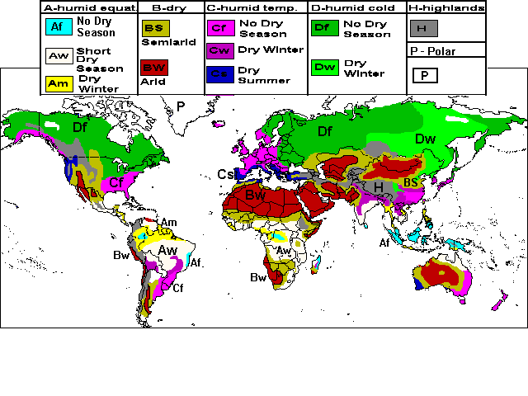

# 4. FACTORS AFFECTING CLIMATE AND WEATHER

# air temperature

# air humidity

# type and amount of cloudiness

# type and amount of precipitation

# air pressure

# wind speed and direction

# climate controls drive atmospheric processes

# [*Climate* *Control* handout]

# latitude

# ocean currents

# wind and air masses

# elevation

# relief

# near water

# 5. AIR MASSES AND FRONTS

# air mass – large mass of air with nearly uniform temperature and humidity that moves mostly in a horizontal direction

# source region defines temperature and moisture characteristics, and classification

# polar – cold

# tropical – warm

# equatorial – originating near equator

# maritime – moist

# continental – dry

# front - boundary between two different interacting air masses

# [*Identifying Air Masses and Fronts* handout]

# 6. INTERPRETING THE WEATHER

# Climographs are a graphic way of displaying average temperature and rainfall



# data used in interpreting weather:

# temperature type of weather

# dew point temperature cloud cover

# air pressure wind direction and speed

# [*Interpreting Surface Observation Symbols* handout]

# 7. WEATHER DISTURBANCES

# TORNADOES

|  |  |  |
| --- | --- | --- |
| Before thunderstorms develop, a change in wind direction and an increase in wind speed with increasing height create an invisible, horizontal spinning effect in the lower atmosphere. | Rising air within the thunderstorm updraft tilts the rotating air from horizontal to vertical. | An area of rotation, 2-6 miles wide, now extends through much of the storm. Most strong and violent tornadoes form within this area of strong rotation. |

# Types

# multiple vortex tornado water spout

# satellite tornado land spout

# Characteristics

# shape rotation

# size sound

# appearance electromagnetic

# Fujita Tornado Intensity Scale

# HURRICANES

# Stages of Development

|  |  |  |
| --- | --- | --- |
|  |  |  |

# Parts of a Hurricane

# Outflow The Eye The Eye Wall

# Feeder Bands Storm Surge

# Saffir-Simpson Scale

# 